Police Officer Applicant,

Welcome to the application process for the position of Silvis Police Officer. Please return or email your completed Application, Notice and Authorization form, and Police Officer Liability Waiver to the Silvis Police Department by 1:00 PM on Monday July 7th, 2025. If you choose to email your application, email to [emorgan@silvispd.org](mailto:emorgan@silvispd.org). Applications can be found online at [www.silvisil.org](http://www.silvisil.org) or you can pick one up at the Silvis Police Department. I encourage you to include a cover letter and resume.

The City of Silvis Civil Service Commission will conduct physical testing on Saturday July 12th, 2025 beginning at 9:00 AM at the Silvis Police Department. Written testing will be the same day at 1:00 PM in the Silvis Police Department Community Room. You must pass all physical tests to continue on to written testing. Physical testing is based on the Illinois Law Enforcement Training and Standards Board POWER test requirements. State issued photo identification must be presented to be eligible to participate in the testing. No electronic devices or ball-caps will be allowed inside the written testing area.

Silvis Police Department: 600 Illini Drive, Silvis, IL 61282. Additional parking is located across the street to the north in the hospital parking lot.

Thank you for your interest in joining the Silvis Police Department.

Good Luck,

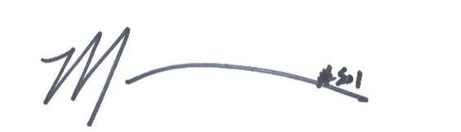

Chief Mark VanKlaveren